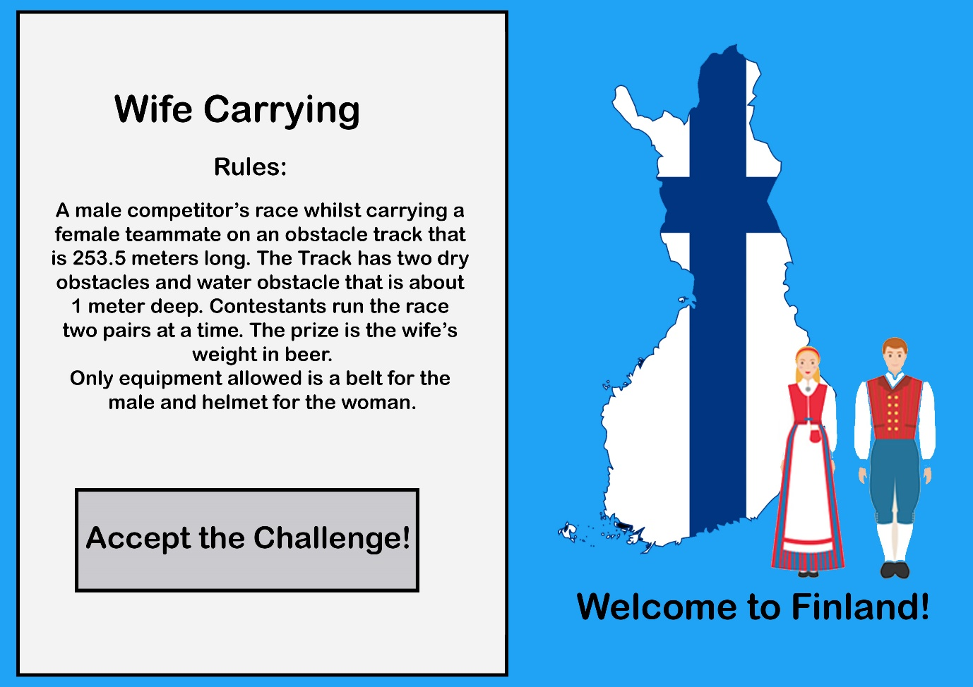
https://it.wikipedia.org/wiki/File:Finland_stub_POL.svg
https://www.istockphoto.com/gb/vector/finnish-woman-and-man-in-traditional-costume-gm962795576-262967914
